GST00500 –APPROVAL

USER INTERFACE

Inbox
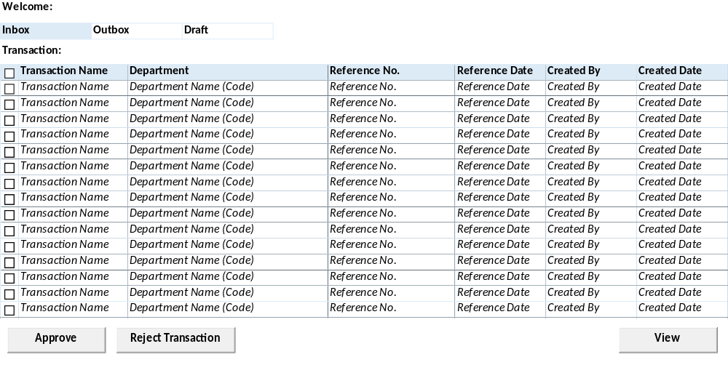

Outbox
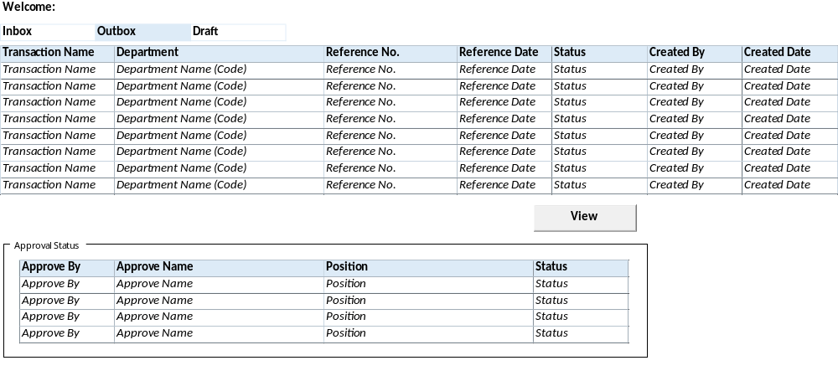

Draft
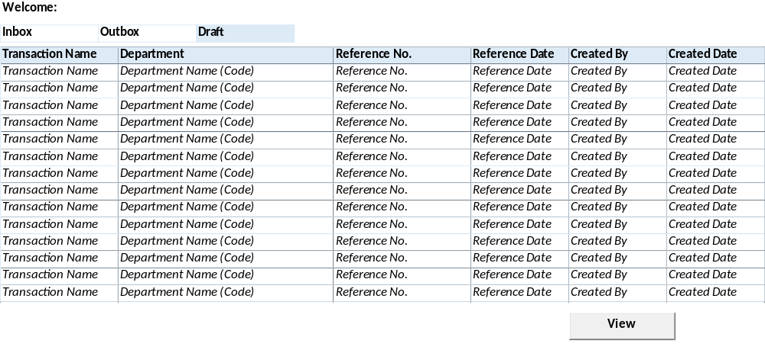

BUTTON DEFINITION
Test
- X – untuk keluar dari program

OUTPUT
Test
- None.

ROLES
Test
- Program ini dijalankan oleh User sesuai Login Id.

INITIAL PROCESS
Test
- Load Form:
- Baca database master User join User-Company ditampilkan pada label Welcome.
[CR01]
SELECT B.CUSER_NAME FROM SAM_USER_COMPANY A (NOLOCK)
INNER JOIN SAM_USER B (NOLOCK) ON B.CUSER_ID = A.CUSER_ID
WHERE A.CCOMPANY_ID = [LOGIN COMPANY ID] AND A.CUSER_ID = [LOGIN USER ID]

EXEC RSP_GS_GET_USER_DETAIL [LOGIN COMPANY ID], 'GST00500', [LOGIN USER ID], ''
[CR01/]

- Pages: Inbox, Outbox, Draft.

- Jalankan "DISPLAY PROCESS"
- Set Focus pada page "Inbox"

DISPLAY PROCESS
Test
- Welcome: B.CUSER_NAME (lihat Initial Process)
- PAGE INBOX
  - Onactive(
    - Baca database transaksi Approval Inbox yang ready untuk User tersebut dan ditampilkan pada list of Inbox.
[CR01]
SELECT VAR_SELECTED = 0, A.*, C.CDESCRIPTION AS CAPPROVAL_STATUS_DESC, B.CTRANSACTION_NAME, B.CTABLE_NAME, B.CPROGRAM_ID
^{FROM GST_APPROVAL_I A (NOLOCK)}
INNER JOIN GSM_TRANSACTION_CODE B (NOLOCK) ON B.CCOMPANY_ID = A.CCOMPANY_ID AND B.CTRANSACTION_CODE = A.CTRANSACTION_CODE
INNER JOIN RFT_GET_GSB_CODE_INFO('SIAPP', [LOGIN USER].[CCOPANY_ID], '_GS_APPROVAL_STATUS', '', [LOGIN USER].[CLANGUAGE_ID]) C ON C.CCODE = A.CAPPROVAL_STATUS
WHERE A.CUSER_ID = [LOGIN USER ID] AND A.CAPPROVAL_STATUS = '01' AND A.CTRANSACTION_STATUS IN ('01','02')
ORDER BY B.CTRANSACTION_NAME, A.CREFERENCE_DATE ASC

EXEC [RSP_GS_GET_APPR_TRX_LIST] [Login Company Id], [User Login Id], 'I'

[CR01/]

  - List of Inbox
    - Definisi Fields:
      - "Selected"
        - Checkbox
        - Display = Var_Selected
        - Enabled
      - "Transaction Name"
        - Textbox
        - Display = [CR01] B.CTRANS_NAME
      - "Department"
        - Textbox
        - Display = A.CDEPT_CODE
      - "Reference No"
        - Textbox
        - Display = [CR01] A.CREF_NO
      - "Reference Date"
        - Textbox
        - Display = [CR01] A.CREF_DATE
      - "Create Date"
        - Textbox
        - Display = A.DCREATE_DATE
      - "Create By"
        - Textbox
        - Display = A.CCREATE_BY

  - Button Definition:
    - Approve – untuk melakukan approval terhadap dokumen
    - Reject Transaction – untuk membatalkan dokumen (dilakukan biasanya oleh User dengan level yang lebih tinggi dibanding pembuat dokumen).
      - Onclick:
        - Display Message.Question("Are You sure want process these records?") With Yes and No option
        - If “Yes”, run “Reject Process” as Popup form
        - If “No”, cancel Reject Process
    - View – untuk melihat detail dokumen dengan memanggil program yang bersangkutan
    - Enabled all buttons

- PAGE OUTBOX
  - Onactive(
    - Baca database transaksi Approval Outbox yang Open dan Inprogress untuk User tersebut dan ditampilkan pada list of Outbox.
[CR01]
SELECT VAR_SELECTED = 1, A.*, C.CDESCRIPTION AS CTRANSACTION_STATUS_DESC, B.CTRANSACTION_NAME, B.CPROGRAM_ID FROM GST_APPROVAL_O A (NOLOCK)
INNER JOIN GSM_TRANSACTION_CODE B (NOLOCK) ON B.CCOMPANY_ID = A.CCOMPANY_ID AND B.CTRANSACTION_CODE = A.CTRANSACTION_CODE
INNER JOIN DBO.RFT_GET_GSB_CODE_INFO('SIAPP', [LOGIN USER].[CCOPANY_ID], '_STATUS_FLAG_01', '', [LOGIN USER].[CLANGUAGE_ID]) C ON C.CCODE = A.CTRANSACTION_STATUS
WHERE A.CUSER_ID = [LOGIN USER ID] AND A.CTRANSACTION_STATUS IN ('01','02')
ORDER BY B.CTRANSACTION_NAME, A.CREFERENCE_DATE ASC

EXEC [RSP_GS_GET_APPR_TRX_LIST] [Login Company Id], [User Login Id], 'O'
[CR01/]

    - Baca database transaksi Approval Inbox yang sesuai Reference No dokumen yang bersangkutan dan ditampilkan pada list of Approve by – Outbox.
[CR01]
SELECT C.*, D.CUSER_NAME, D.CPOSITION, E.CDESCRIPTION AS CAPPROVAL_STATUS_DESC FROM GST_APPROVAL_I C (NOLOCK)
INNER JOIN SAM_USER D (NOLOCK) ON D.CUSER_ID = C.CUSER_ID
INNER JOIN RFT_GET_GSB_CODE_INFO ('SIAPP', [LOGIN USER.CCOMPANY_ID], '_GS_APPROVAL_STATUS', '', [LOGIN USER.CLANGUAGE_ID]) E ON C.CAPPROVAL_STATUS = E.CCODE
WHERE C.CCOMPANY_ID = 'A.CCOMPANY_ID '
AND C.CTRANSACTION_CODE = 'A.CTRANSACTION_CODE '
AND C.CDEPT_CODE = 'A.CDEPT_CODE '
AND C.CREFERENCE_NO = 'A.CREFERENCE_NO '
ORDER BY C.CUSER_ID, C.ISEQUENCE ASC

EXEC [RSP_GS_GET_APPROVER_LIST] [Login Company Id], [Selected CTRANS_CODE], [Selected CDEPT_CODE], [Selected CREF_NO], [User Login Id]
[CR01/]

  - List of Outbox
    - Definisi Fields:
      - "Transaction Name"
        - Textbox
        - Display = [CR01] B.CTRANS_NAME
      - "Department"
        - Textbox
        - Display = A.CDEPT_CODE
      - "Reference No"
        - Textbox
        - Display = [CR01] A.CREF_NO
      - "Reference Date"
        - Textbox
        - Display = [CR01] A.CREF_DATE
      - "Status"
        - Textbox
        - A.CTRANS_STATUS_DESC
      - "Created Date"
        - Textbox
        - Display = A.DCREATE_DATE
      - "Created By"
        - Textbox
        - Display = A.CCREATE_BY
    - Read Only.
  - Button Definition:
    - View – untuk melihat detil dokumen dengan memanggil program yang bersangkutan
    - Enabled button.View
  - List of Approval Status
    - Definisi Fields:
      - "Approve By"
        - Textbox
        - Display = C.CUSER_ID
      - "Approve Name"
        - Textbox
        - Display = D.CUSER_NAME
      - "Position"
        - Textbox
        - Display = D.CPOSITION
      - "Status"
        - Textbox
        - Display = C.CAPPROVAL_STATUS_DESC
    - Read Only.

- PAGE DRAFT
  - Onactive(
    - Baca database transaksi Approval Outbox yang Draft untuk User tersebut dan ditampilkan pada list of Draft.
[CR01]
SELECT VAR_SELECTED = 1, A.*, B.CTRANSACTION_NAME, B.CPROGRAM_ID FROM GST_APPROVAL_O A (NOLOCK)
INNER JOIN GSM_TRANSACTION_CODE B (NOLOCK) ON B.CCOMPANY_ID = A.CCOMPANY_ID AND B.CTRANSACTION_CODE = A.CTRANSACTION_CODE
WHERE A.CUSER_ID = [LOGIN USER ID] AND A.CTRANSACTION_STATUS = '00'

EXEC [RSP_GS_GET_APPR_TRX_LIST] [Login Company Id], [User Login Id], 'D'
[CR01/]

  - List of Outbox
    - Definisi Fields:
      - "Transaction Name"
        - Textbox
        - Display = [CR01] B.CTRANS_NAME
      - "Department"
        - Textbox
        - Display = A.CDEPT_CODE
      - "Reference No"
        - Textbox
        - Display = [CR01] A.CREF_NO
      - "Reference Date"
        - Textbox
        - Display = [CR01] A.CREF_DATE
      - "Update Date"
        - Textbox
        - Display = A.DCREATE_DATE
      - "Update By"
        - Textbox
        - Display = A.CCREATE_BY
  - Button Definition:
    - View – untuk melihat detil dokumen dengan memanggil program yang bersangkutan
    - Enabled all buttons

“Page.Inbox.Approve” PROCESS
Test
- Display Message.Question(“Are You sure want process these records?”) With Yes and No option
- If No then Return
- Read only list of Inbox
- Process:
  - Update database transaksi Approval Inbox status menjadi “Approved”
[CR01]
For Each Inbox.Var_Selected = 1

WITH Inbox.CurrentSelectedRecord:

Run Function Locking Table With Parameters: .CTABLE_NAME + PK:.CCOMPANY_ID And .CTRANSACTION_CODE And .CDEPT_CODE And .CREFERENCE_NO
^{If Error Then}
Add Message.Information(“This record With .CCOMPANY_ID And .CTRANSACTION_CODE And .CDEPT_CODE And .CREFERENCE_NO has been locked by another user”)
^{Next}
^{End if}

^{BEGIN TRANSACTION:}

^{/* Lock record by SQL */}
Select CCOMPANY_ID From .CTABLE_NAME (Updlock) Where CCOMPANY_ID = .CCOMPANY_ID And CTRANS_CODE = .CTRANSACTION_CODE And CDEPT_CODE = .CDEPT_CODE And CREF_NO = .CREF_NO And CTRANS_STATUS In (01,02)

/* Update Status Ready to be Approved */
^{UPDATE GST_APPROVAL_I}
^{SET CAPPROVAL_STATUS} ^{= '02'}
^{FROM GST_APPROVAL_I A (NOLOCK)}
^{WHERE A.CCOMPANY_ID} ^{= Selected.CCOMPANY_ID}
^{AND A.CTRANSACTION_CODE} ^{= Selected.CTRANSACTION_CODE}
^{AND A.CDEPT_CODE} ^{= Selected.CDEPT_CODE}
^{AND A.CREFERENCE_NO} ^{= Selected.CREFERENCE_NO}
^{AND A.CUSER_ID} ^{= [LOGIN USER ID]}
^{AND A.CAPPROVAL_STATUS} ^{= '01'}

^{If Error Then}
^{ROLLBACK TRANSACTION}
Add Message.Information(“This record With .CCOMPANY_ID And .CTRANS_CODE And .CDEPT_CODE And .CREF_NO has been failed when update status Approved”)
^{Next}
^{End If}

^{COMMIT_TRANSACTION}

^{End WITH}

EXEC RSP_GS_MAINTAIN_APPROVAL [Login Company Id], [Selected Trans Code], [Selected CDEPT_CODE], [Selected CREF_NO], '', '', [Login User Id],'01'

[CR01/]

Display all Messages, Ok
End for
- Jalankan “DISPLAY PROCESS”

“Page.Inbox.Reject” PROCESS
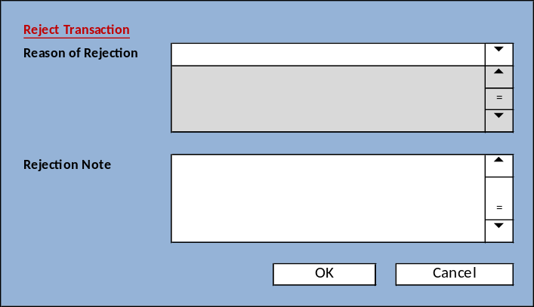
Test
Display Process
- Combobox. “Reason of Rejection”
  - Enabled
  - Field = [A.CREASON_CODE]
  - Value:
    - SELECT * FROM RFT_GET_GSB_CODE_INFO(‘SIAPP’, [Login User].[CCOMPANY_ID], ‘_GS_REJECTTRANS_REASON’, ‘’, [Login User].[CLANGUAGE_ID])
- Editbox. “Rejection Note”
  - Enabled
  - Value = A.TNOTES

Button Definition
- OK, Onclick: Execute “Process”
- Cancel: Onclick: Close form
- Read only list of Inbox
- Process:
  - Validation:
    - If field “Reason of Rejection” is empty: Raise error message “Please select “Reason of Rejection””, skip next processes
    - If field “Rejection Note” is empty, raise error message “Please insert “Rejection Note””, skip next processes
  - Update database transaksi Approval Inbox status menjadi “Cancel”
[CR01]
For Each Inbox.Var_Selected = 1

WITH Inbox.CurrentSelectedRecord:

Run Function Locking Table With Parameters: .CTABLE_NAME + PK:.CCOMPANY_ID And .CTRANSACTION_CODE And .CDEPT_CODE And .CREFERENCE_NO
^{If Error Then}
Add Message.Information(“This record With .CCOMPANY_ID And .CTRANSACTION_CODE And .CDEPT_CODE And .CREFERENCE_NO has been locked by another user”)
^{Next}
^{End if}

^{BEGIN TRANSACTION:}

^{/* Lock record by SQL */}
Select CCOMPANY_ID From .CTABLE_NAME (Updlock) Where CCOMPANY_ID = .CCOMPANY_ID And CTRANSACTION_NAME = .CTRANSACTION_CODE And CDEPT_CODE = .CDEPT_CODE And CREFERENCE_NO = .CREFERENCE_NO And CTRANSACTION_STATUS In (01,02)

/* Update Status Ready to be Canceled */
^{Update GST_APPROVAL_I}
^{Set CAPPROVAL_STATUS} ^{= '03'}
^{, CREASON_CODE} ^{= [Reason for Cancel]}
^{, TNOTES} ^{= [Notes for Cancel]}
^{FROM GST_APPROVAL_I A (NOLOCK)}

^{If Error Then}
^{ROLLBACK TRANSACTION}
Add Message.Information(“This record With .CCOMPANY_ID And .CTRANSACTION_CODE And .CDEPT_CODE And .CREFERENCE_NO has been failed when update status Canceled”)
^{Next}
^{End If}

^{COMMIT_TRANSACTION}

^{End WITH}
EXEC RSP_GS_MAINTAIN_APPROVAL [Login Company Id], [Selected Trans Code], [Selected CDEPT_CODE], [Selected CREF_NO], [Reject Reason], [Reject Notes], [Login User Id], '09'

[CR01/]

Display all Messages, Ok
End for

“Page.Inbox.View” PROCESS
Test
- Button Detail
- WITH Inbox.CurrentSelectedRecord:
  - Set Var_Company_Id = .CCOMPANY_ID
  - Set Var_Transaction_Code = .CTRANSACTION_CODE
  - Set Var_Department_Code = .CDEPT_CODE
  - Set Var_Reference_No = .CREFERENCE_NO
  - Run program .CPROGRAM_ID With Parameters: Var_Company_Id And Var_Transaction_Code And Var_Department_Code And Var_Reference_No + Access View Only
- End WITH

“Page.Outbox.View” PROCESS
Test
- Button Detail
- WITH Outbox.CurrentSelectedRecord:
  - Set Var_Company_Id = .CCOMPANY_ID
  - Set Var_Transaction_Code = .CTRANSACTION_CODE
  - Set Var_Department_Code = .CDEPT_CODE
  - Set Var_Reference_No = .CREFERENCE_NO
  - Run program .CPROGRAM_ID With Parameters: Var_Company_Id And Var_Transaction_Code And Var_Department_Code And Var_Reference_No + Access View Only
- End WITH

“Page.Draft.View” PROCESS
Test
- Button Detail
- WITH Draft.CurrentSelectedRecord:
  - Set Var_Company_Id = .CCOMPANY_ID
  - Set Var_Transaction_Code = .CTRANSACTION_CODE
  - Set Var_Department_Code = .CDEPT_CODE
  - Set Var_Reference_No = .CREFERENCE_NO
  - Run program .CPROGRAM_ID With Parameters: Var_Company_Id And Var_Transaction_Code And Var_Department_Code And Var_Reference_No + Access View Only
- End WITH

“Tutup” PROCESS
Test
- Tutup program

CR LIST
CR No. | Description | Notes
CR01  RE, 14 Sept 2023 | Mengubah query ke dalam bentuk SP

